**Assembly Assignments Fall 2020**

The assignments are individual tasks you have to do these codes by yourself.

1. Take four inputs and calculate 1st sum, then subtract, then sum then subtract.

**Input and Output:** 3 4 **7** 5 **2** 6 **8** 7 **1**

**Output**

**Explain:** 3 + 4 = 7 - 5 = 2 + 6 = 8 - 7 = 1

1. Write a **single program** which will take uppercase string and print the string to lowercase then take lowercase string input and print uppercase of the string.

**Input Length of Upper String:** 4

**Input Enter String Here:** ULAB

**Output:** ulab

**Input Length of lower String:** 5

**Input Enter String Here:** dhaka

**Output:** DHAKA

1. As I have uploaded a code which was find max from N numbers, there was an error in the code. At first you have to resolve the code. Then, write **a single code** which will take N input from user and find out max, again take N input from user and find out min.

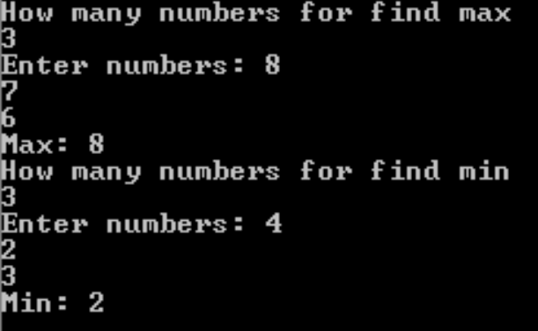

1. Write a code which will take input a number which is more than one digit and check whether it is divisible by 2 or not.
2. Convert a decimal number into octal number.

**Input:** 9

**Output:** 1001

1. Take N input and find which one in even or odd. If even print ‘e’ else print ‘o’

**Input and Output:**

**7**

**9o4e6e1o5o2e7o**

**Important Note**

∙ Cheating or copying of assignment is strictly prohibited; both will get zero mark in that case.

∙ Viva will be taken**.**

**SUBMISSION DEADLINE: 8/12/2020**